Forces on Crust and Plate Boundaries # ________
Forces That Move and Deform the Crust:
1. Compression – are forces which push toward each other along a single line of motion (squeezing)
Diagram:

2. Tension – is the force that pushes or pulls away from each other along a single line of motion.

3. Shear – forces which act in opposite directions along different lines of motion

The 3 Forces and Plate Boundaries
Tension – located where the plates are spreading apart. (Divergent Boundary) occur at mid-ocean ridges: sea floor spreads apart where magma rises upward.

- Mid-ocean ridges result from divergent boundaries.
- The border between two plates is called a boundary.
- Divergent boundary a place where two plates are moving apart
- New rock forms between divergent boundaries.
- Magma liquid rock produced under Earth’s surface
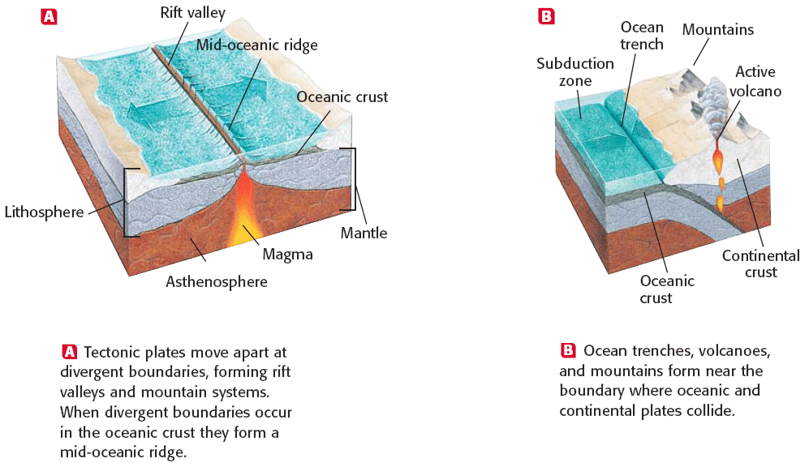

- Compression – located where plates collide (Convergent Boundary) occur along the edges of continents. Areas have folded mountains & trenches in areas known as (subduction zones)

- Oceanic plates dive beneath continental plates at convergent boundaries.

- Plates slide over each other at a convergent boundary.

- Subduction the process by which one lithospheric plate moves beneath another as a result of tectonic forces

- The area where one plate slides over another is called a subduction zone. Subduction zones produce ocean trenches, mountains, and volcanoes.

Subduction of ocean crust generates volcanoes.
Chains of volcanoes form on the upper plate in a subduction zone.
These volcanoes can form far inland from their associated oceanic trench.
Colliding tectonic plates create mountains.
  - When two plates collide, mountains are formed at the boundary of the collision.
  - The Himalayas formed during the collision between the continental tectonic plate containing India and the Eurasian continental plate.

Shear – located where the plates slide past each other. (Neutral Boundary) strike-slip faults - - best example San Andreas Fault.

- Transform fault boundaries can crack Earth.
- Plate movement can cause breaks in the lithosphere.
- Fault a crack in Earth created when rocks on either side of a break move
- Plate movement at transform fault boundaries is one cause of earthquakes.
