Geode | Name __________________________ Date _______ Pd ___

STEP I
A Geode (Greek for "earthlike") is a geological secondary structure which occurs in certain sedimentary and volcanic rocks. They can be of sedimentary origin and are formed by chemical precipitation. Geodes are hollow, vaguely spheroid to oblate masses of mineral matter, which may include crystals, that form either by the filling of vesicles in volcanic to sub-volcanic rocks by minerals deposited from hydrothermal fluids or by the dissolution of igneous nodules. Some can form by the minerals precipitating from groundwater or in areas of hot geothermal fluids.
Geodes also differ from nodules in that a nodule is a mass of mineral matter that has accreted around the nodule nucleus. Both structures had the minerals contained within, deposited from groundwater. Geodes commonly have microcrystal masses of silicate minerals such as quartz. The shell is lined internally by various minerals, often as crystals, sometimes calcite, pyrite, sphalerite, barite, celestite, limonite, and opal. Quartz is by far the most common and abundant mineral found in geodes. Geodes are found mostly in basaltic lavas and limestones. The Warsaw rock formation in the region near where the Missouri, Iowa, and Illinois borders meet is an example of one region where geodes are abundant.
Geode banding and coloration is the result of variable impurities. Iron oxides will impart rust hues to siliceous solutions, such as the commonly observed iron-stained quartz. Most geodes contain clear quartz crystals, while others have purple amethyst crystals. Still others can have agate, or jasper banding or crystals such as calcite, dolomite, and celestite. There is no easy way of telling what the inside of a geode holds until it is cut open or broken apart. However, geodes from a particular area are usually similar in appearance.
NOW: Complete the statements to the right.

STEP III
Find and circle you answers on the grid below. Note: Words can read in any direction.
Q U A R T Z G S N E W E
O L A R E N I M O L O E
E E T I C L A C I P L A
D D E C I A L P T R L R
I T O C A A L O A U O T
F T A E V H E W R P H H
O T R A G L D I O S L L
E O S I O N I L L I C I
R E T A W D N U O R G K
A T E D I N I O C W A E
E U O K S Z R D Q G A B
I Y T T Z C A S V R L I
STEP IV
Now read left to right, row by row, the letters you have not circled for a hidden message about the work sheet topic. Write it here:

G________________ C ___________________ of the W __________________

is L_________________________ in I ________________ .
# _____

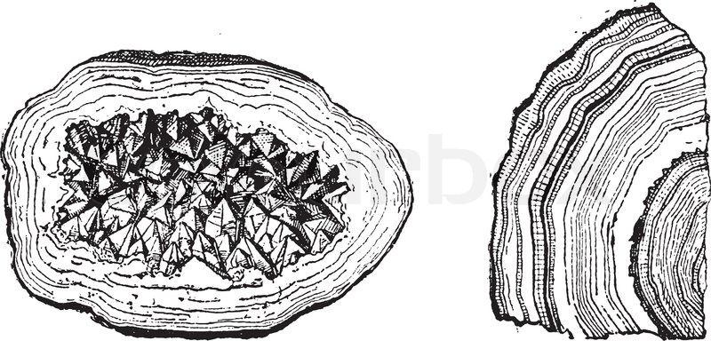

STEP II
Write in the missing word to complete the statements below.

1. Geode banding and ____________________is the
result of variable impurities.

2. Geodes are __________________, vaguely spheroid
to oblate masses of mineral matter.

3. __________________ is by far the most common
and abundant mineral found in geodes.

4. Geode is a Greek word that with a meaning or
translates to _________________________.

5. Geodes commonly have a microcrystal masses of
________________ minerals such as quartz.

6. There is no easy way of telling what the inside of a
_________________ holds until it is cut open or
broken apart.

7. Geodes are found mostly in basaltic ____________
and limestones.

8. Geodes can form by the minerals precipitating
from _____________________ or in areas of hot
geothermal fluids.

9. Some geodes have _________________ amethyst
crystals.

10. Geodes are abundant in the Warsaw rock
formation in the region near where the Missouri,
Iowa, and ____________________ borders meet

11. Sometimes geodes can have agate, or jasper
banding or crystals such as _________________,
dolomite, and celestite.

12. Geodes also differ from nodules in that a nodule is
a mass of ____________________ matter that has
accreted around the nodule nucleus.

