INSIDE OUR EARTH – Handout # _______ | Name ___________________________ Date _______ Pd __

STEP I
Our earth is called the lithosphere. Some scientists believe that at one time, over four billion years ago, it was a rotating mass of gases going around the sun. As the gases cooled they came together. The heaviest molecules went to the inside. Our earth may have developed in this way.
The center section of the earth is called its core. It appears to be made up of heavy iron and nickel molecules. The core seems to be about 2100 miles thick. Lighter weight molecules form the mantle. The mantle is less dense than the core, and is about 1800 miles thick. The outer surface of the earth is the crust. It is as little as seven miles thick under the ocean, to 20 miles thick under high mountains. It is made up of lighter-weight rock and soil.
By studying earthquake waves scientists have been able to find these regions inside our earth. The mantle is made of solid, heavy rock. The outer part of the core seems to be melted, and the inner-part of the core seems to be solid. Earthquake waves change their direction when they reach the mantle. This boundary between the crust and the mantle is called the “Moho.” Earthquake waves do not go directly through the outer core. This indicates that it is probably melted. The deeper man drills the hotter the rocks become.

NOW: Complete the statements to the right.

STEP III
Find and circle you answers on the grid below. Note: Words can read in any direction.

L | N | S | E | L | U | C | E | L | O | M
D | I | R | E | C | T | I | O | N | T | A
H | C | T | E | F | O | S | R | T | C | N
E | K | S | H | M | N | O | F | O | G | T
R | E | A | V | O | I | T | T | G | A | L
T | L | I | I | H | S | S | O | E | N | E
A | R | G | E | O | U | P | W | T | H | A
T | E | H | O | R | L | D | H | H | Y | O
R | U | R | C | E | G | A | S | E | S | A
R | R | O | C | K | T | H | T | R | R | O
G | E | T | C | O | R | E | H | E | R | E
STEP IV
Now read left to right, row by row, the letters you have not circled for a hidden message about the solar system. Write it here:
_________________________________________________
_________________________________________________
_________________________________________________

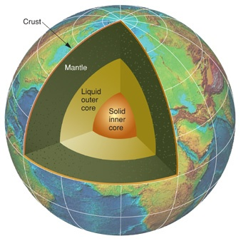
REGIONS INSIDE THE EARTH

STEP II
Write in the missing word to complete the statements below.

- By studying earthquakes scientists have been able to find the _________________________ inside our earth
- This region of the earth is less dense than the core, and is about 1800 miles thick.
__________________
- The heaviest _____________________ went to the center of the earth.
- Our earth is called the ___________________.
- Over four billion years ago our earth may have been a rotating mass of ___________.
- Our earth’s core appears to be made up of heavy iron and __________________ molecules.
- The mantle is made up of solid, heavy _________________.
- Earthquake waves change ___________________ when they reach the mantle.
- The boundary between the crust and the mantle. _____________
- The outer surface of the earth is the ________________.
- The center section of the earth.
________________
- As the gases cooled they came _____________

