|  |  |
| --- | --- |
| **Plate Tectonics** | Name ___________________________ Date _______ Pd __ |

**STEP I**

Plate tectonics from the [Late Latin](http://en.wikipedia.org/wiki/Late_Latin) tectonicus, and [Greek](http://en.wikipedia.org/wiki/Greek_language): pertaining to building is a [scientific theory](http://en.wikipedia.org/wiki/Scientific_theory) that describes the large scale motions of [Earth](http://en.wikipedia.org/wiki/Earth)'s [lithosphere](http://en.wikipedia.org/wiki/Lithosphere). The theory builds on the concepts of [continental drift](http://en.wikipedia.org/wiki/Continental_drift), developed during the first decades of the 20th century, and accepted by the majority of the geoscientific community when the concepts of [seafloor spreading](http://en.wikipedia.org/wiki/Seafloor_spreading) were developed in the late 1950s and early 1960s. The first to write of this theory was Alfred Wegner who was scorned due to the lack of proof.

The [lithosphere](http://en.wikipedia.org/wiki/Lithosphere) is broken up into [tectonic plates](http://en.wikipedia.org/wiki/List_of_tectonic_plates). In the case of the Earth, there are currently seven or eight major depending on how they are defined and many minor plates. The lithospheric plates ride on the [asthenosphere](http://en.wikipedia.org/wiki/Asthenosphere). These plates move in relation to one another at one of three types of plate boundaries: [convergent](http://en.wikipedia.org/wiki/Convergent_boundary), or collision boundaries; [divergent](http://en.wikipedia.org/wiki/Divergent_boundary) boundaries, also called spreading centers; and conservative [transform](http://en.wikipedia.org/wiki/Transform_fault) boundaries. A transform area is also known as a neutral boundary and one of the best example areas is the San Andreas Fault zone. [Earthquakes](http://en.wikipedia.org/wiki/Earthquake), [volcanic activity](http://en.wikipedia.org/wiki/Volcano), [mountain](http://en.wikipedia.org/wiki/Mountain)-building, and [oceanic trench](http://en.wikipedia.org/wiki/Oceanic_trench) formation occur along these plate boundaries. The lateral relative movement of the plates typically varies from 0 - 100 mm annually. The average motion of plates is around two centimeters a year.

The tectonic plates are composed of two types of [lithosphere](http://en.wikipedia.org/wiki/Lithosphere): thicker continental and thin oceanic. This means that a plate can be of one type, or of both types. One of the main points the idea proposes is that the amount of surface of the continental or oceanic plates that disappears in the mantle along the convergent boundaries by [subduction](http://en.wikipedia.org/wiki/Subduction) is more or less in equilibrium with the new crust that is formed along the divergent margins by [seafloor spreading](http://en.wikipedia.org/wiki/Seafloor_spreading). This is also referred to as the conveyor belt principle. In this way, the total surface of the globe remains the same. This is in contrast with earlier theories advocated before the Plate Tectonics concept. Before it became the main scientific model, many theories had proposed gradual shrinking or contraction or gradual expansion of the globe.

Tectonic plates are able to move because the Earth's lithosphere has a higher strength and lower density than the underlying asthenosphere. The different density variations in the mantle result in [convection](http://en.wikipedia.org/wiki/Mantle_convection) currents which move the plates. Their movement is thought to be driven by a combination of the motion of seafloor away from the spreading ridge due to variations in topography and density of the crust that result in [differences in gravitational forces](http://en.wikipedia.org/wiki/Earth%27s_gravity#Variation_in_gravity_and_apparent_gravity) and [drag](http://en.wikipedia.org/wiki/Drag_(physics)), which causes downward motion, at the [subduction](http://en.wikipedia.org/wiki/Subduction) zones.

**NOW: Complete the statements to the right.**

**STEP III**

**Find and circle you answers on the grid below. Note: Words can read in any direction.**

L E B D E N C C H M N O

E A A R I K S O S H O C

G R T O W V E N X A I E

A T G N C T E T E L T A

R H T N E U T R A L C N

E Q H E I N V A G A E I

V U G T I D I C O E V C

A A I N S O L T N E N A

R K E T H V J I N O O T

R E N G E W R O U O C O

S S T L I Q T N P B C W

B O U N D A R I E S H G

**STEP IV**

**Now read left to right, row by row, the letters you have not circled for a hidden message about the work sheet topic. Write it here:**

__ e __ __ __ M __ __ __ __ __ __ __ w

__ __ __ __ _t __ l __ __ __ t __ __ n __

__ __ __ a __ __ __

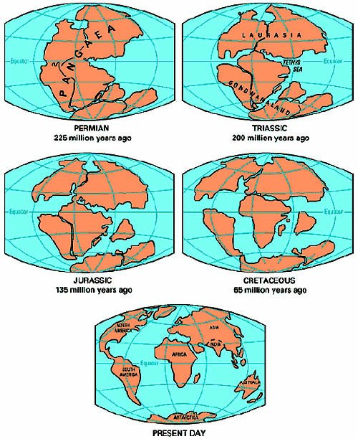

**STEP II**

**Write in the missing word to complete the statements below.**

1. The tectonic plates are composed of two types of [lithosphere](http://en.wikipedia.org/wiki/Lithosphere): thicker continental and thin __________________.
2. The first to write of this theory was Alfred ___________

who was scorned due to lack of proof.

3. The different density variations in the mantle result in

_________________ currents which move the plates.

4. Earth, there are currently seven or _____________

major depending on how they are defined and many

minor plates.

5. The theory builds on the concepts of [_______________](http://en.wikipedia.org/wiki/Continental_drift" \o "Continental drift)

[drift](http://en.wikipedia.org/wiki/Continental_drift" \o "Continental drift), developed during the first decades of the 20th

century.

6. These plates move in relation to one another at one of

three types of plate _________________________.

1. _____________________boundaries, also called

spreading centers is where plates move apart.

8. The _____________________ motion of plates is

around two centimeters a year.

9. A transform area is also known as ________________

boundary and one of the best example areas is the

San Andreas Fault zone.

10. Before it became the main scientific model, many

theories had proposed gradual shrinking or

______________ or gradual expansion of the globe.

11. Plate tectonics from the [Late Latin](http://en.wikipedia.org/wiki/Late_Latin) tectonicus, and

[Greek](http://en.wikipedia.org/wiki/Greek_language): pertaining to ____________________.

1. __________________________, [volcanic activity](http://en.wikipedia.org/wiki/Volcano),

[mountain](http://en.wikipedia.org/wiki/Mountain)-building, and [oceanic trench](http://en.wikipedia.org/wiki/Oceanic_trench) formation occur

along these plate boundaries