Plate Tectonics # _________
- Around 1915, German scientist Alfred Wegener proposed the idea that the continents were once united as a supercontinent and then drifted apart.
- He pieced the continents together like a puzzle and called the supercontinent they formed Pangaea.
- Wegener found identical fossils on widely separate continents, which supported his idea.

- Evidence for Wegener’s ideas came later.

- Wegener’s theory of continental drift was ignored until structures discovered on the ocean floor provided evidence for a mechanism for the movement of continents.

- Symmetrical bands on either side of a mid-ocean ridge indicate that the two sides of the ridge were moving away from each other and new ocean floor was rising up between them.

- Alignment of oceanic rocks supports the theory of moving plates.
- Iron in molten rock aligns itself with Earth’s magnetic field as it cools.
- The Earth’s magnetic field reverses polarity about every 200,000 years
- The process is recorded as magnetic bands in rock, based on the age of the rock.
- Symmetrical bands on either side of the Mid Atlantic Ridge suggest that the crust was moving away from the ridge.

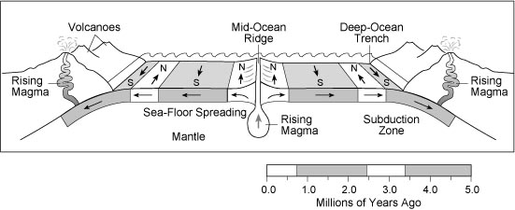
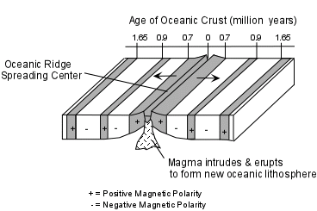

- Earth has plates that move over the mantle.
- The crust and upper portion of the mantle are divided into about seven large pieces called tectonic plates.
- Lithosphere the solid, outer layer of Earth, that consists of the crust and the rigid upper mantle

- Plate tectonics the theory that explains how the outer parts of Earth change through time, and that explains the relationships between continental drift, sea-floor spreading, seismic activity, and volcanic activity
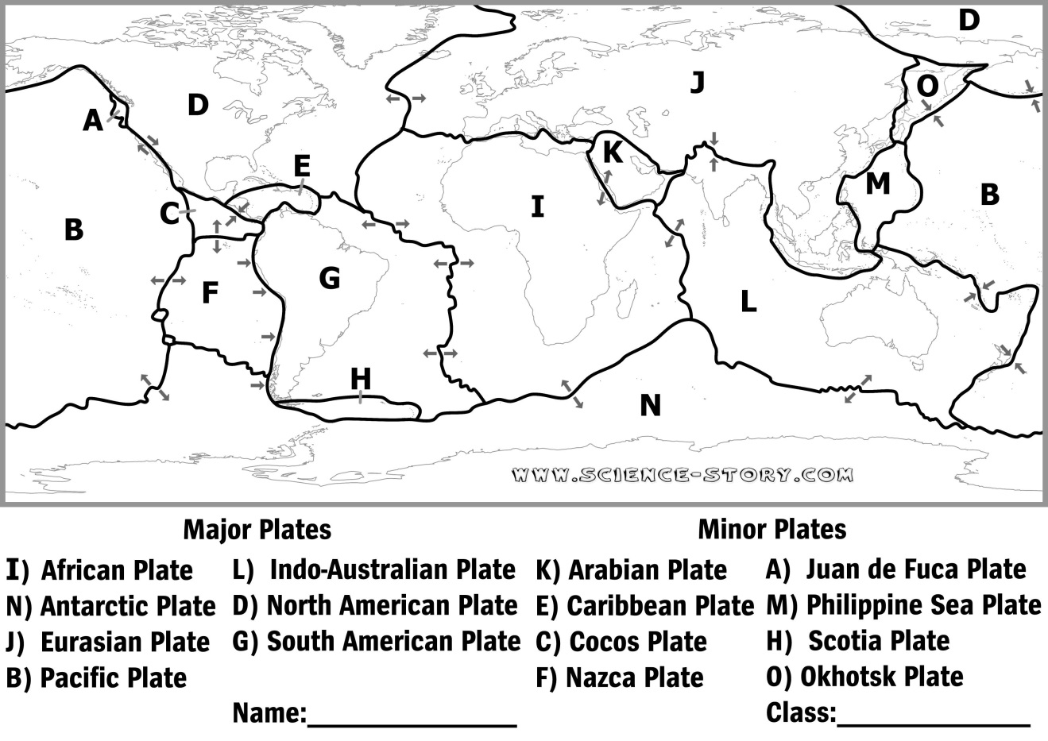
- It is unknown exactly why tectonic plates move.
- One hypothesis suggests that plate movement results from convection currents in the asthenosphere, the hot, fluid portion of the mantle.
- Another hypothesis suggests that plate movement results from the force of gravity acting on the plates.

