Video Crust Name: __________________________ # ______
1. The video today is brought to you by : __________________________________ its hot, its rock, but it doesn’t roll.
2. The crust is a _______________ layer of rock all around the Earth.
3. What does Bill use 1st to model the crust(using a chain saw: _____________________________
4. What is the inner core made of : ____________________________,
5. Label the layers of the Earth: 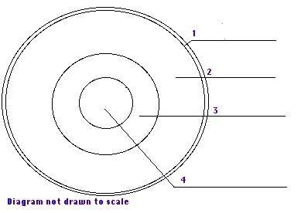
6. Have we drilled through the crust to the mantle? ______________
7. Another example of a model of the layers is a boiled : ______________________
8. What is Richie not doing? __________________________________________ What company is the product he is eating? _____________________________________.
9. What kind of scientist is Dan Dzurisin? _______________________________________________________
10. What volcano are they standing in _______________________ an when did it majorly erupt? _________
11. What does Bill put into the magma? : _______________________________________________________
12. What is it called when hot water erupts from the ground near volcanos ? __________________________
13. What is the name of the one show from # 12? _______________________________________________
14. What two continents gave one of the 1st clues to Plate tectonics? _____________________________ & ____________________________________.
15. When all the plates were together it was called: _____________________________________.
16. What state is the cave where bill is in and showing : _____________________________________
17. What are Cass Thompson and Bill digging for? ____________________________________.
18. A seismograph detects __________________________ occurring in the crust.
19. What occurs due to Richie not eating his crust? _____________________________________________.
20. Who sings the song “Crust” ? ___________________________________________

