Name: ___________________________________________________ Date: ______________________ Period: _______
Dynamic Earth Interactive: Tectonic Plate Boundaries
Use the following website to answer the questions below.
http://www.learner.org/interactives/dynamicearth/plate.html
- Use the map to identify the tectonic plates.
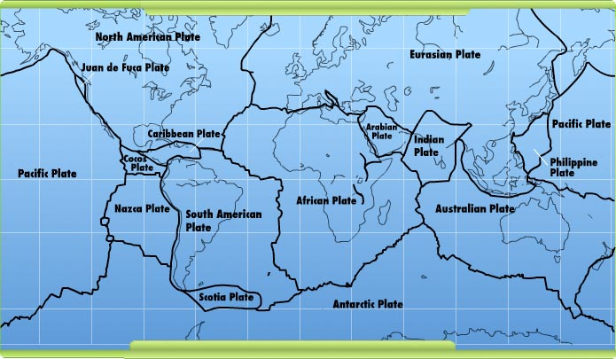
[Grab your reader’s attention with a great quote from the document or use this space to emphasize a key point. To place this text box anywhere on the page, just drag it.]
[Grab your reader’s attention with a great quote from the document or use this space to emphasize a key point. To place this text box anywhere on the page, just drag it.]
[Grab your reader’s attention with a great quote from the document or use this space to emphasize a key point. To place this text box anywhere on the page, just drag it.]
[Grab your reader’s attention with a great quote from the document or use this space to emphasize a key point. To place this text box anywhere on the page, just drag it.]
[Grab your reader’s attention with a great quote from the document or use this space to emphasize a key point. To place this text box anywhere on the page, just drag it.]

- Use the BOTTOM map to see where the three different types of plate boundaries are found throughout the world.
  - Identify two plates at a divergent boundary:
____________________________________ and _________________________________
  - Identify two plates at a convergent boundary:
____________________________________ and _________________________________
  - Identify two plates at a transform boundary:
____________________________________ and _________________________________
Click on the “Slip, Slide, & Collide” Tab at the top of the page.
- Many of the most dramatic ___________________ phenomena we experience on Earth — __________________ eruptions, _______________________, ___________________, and more — are caused by the slipping, sliding, and colliding of tectonic plates. As you might expect by now, most major geologic events occur at the ___________________ between tectonic plates, where huge, massive pieces of the earth's crust ____________. Each kind of plate boundary is associated with particular events, so if you know about the movements taking place at a plate boundary, you can often __________________ what's likely to occur there — volcanoes, earthquakes, ______________________, _____________________ — in the ________________!
Convergent Boundaries – Colliding Plates
- What happens to oceanic crust along a subduction zone? _____________________________________________
___________________________________________________________________________________________
- What is formed along the edge of a continent as the oceanic crust sinks? ________________________________
- What causes magma to form along a subduction zone? _______________________________________________
___________________________________________________________________________________________
- Using the animation of the subduction zone, roll your mouse over the following terms and record their definition:
a.Subduction zone: ___________________________________________________________________________
b.Volcano: __________________________________________________________________________________
c.Volcanic arc: _______________________________________________________________________________
d. Trench: __________________________________________________________________________________
8. The magma formed at a subduction zone ______________ up toward the earth's surface and builds up in ____________________________, where it feeds and creates ____________________ on the overriding plate. When this magma finds its way to the surface through a ___________ in the crust, the volcano ______________, expelling ____________ and __________. An example of this is the band of active volcanoes that encircle the __________________________, often referred to as the _________________________.
9. What geologic event is caused by the collision and subduction of plates? __________________________________
10. What is a tsunami? ___________________________________________________________________________
11. What causes tsunamis? ________________________________________________________________________
12. How many people were killed during the Indian Ocean tsunami in December 2004? ________________________
13. What happens when two continental plates collide? __________________________________________________
______________________________________________________________________________________________
14. How did the Himalayan Mountains form? __________________________________________________________
15. What are two peaks in the Himalayas that are more than 26.000 feet high? ______________________________

Divergent Boundaries – Spreading Plates

16. Divergent boundaries in the middle of the ocean contribute to ______________________________. As plates made of ______________ crust ________________________, a crack in the ocean floor appears. _________ then ____________ up from the mantle to fill in the space between the plates, forming a ______________________ called a _________________________. The magma also spreads __________________, forming ___________ ocean floor and new ________________________.

17. When two ________________________ plates diverge, a _______________________ rift develops. This _____ is a ___________________ zone where the plates are pulling ___________. As the crust _____________ and _________, valleys form in and around the area, as do _________________, which may become increasingly __________. Early in the rift formation, _____________ and ____________ flow into the low valleys and long, narrow ___________ can be created. Eventually, the widening crust along the boundary may become thin enough that a piece of the ____________________________________, forming a ________________________________. At this point, water from the ________________ will rush in, forming a new __________ or ocean _____________ in the rift zone.
*** Play the animation of the formation of a rift valley.

Transform Boundaries – Grinding Plates

18. How do plates move along a transform boundary? ___________________________________________________
19. What is a fault? ______________________________________________________________________________
20. Why do transform boundaries and the resulting faults produce a lot of earthquakes? ________________________
______________________________________________________________________________________________
21. What happens as the plates grind past each other? __________________________________________________
______________________________________________________________________________________________
22. How does the building up of stress along a fault result in an earthquake? ________________________________
_____________________________________________________________________________________________
23. The motion of the plates at a transform boundary has given this type of fault another name — a ____________
_______ fault. The best-studied strike-slip fault is the ___________________ Fault in California. It is located at the boundary between the ______________ and __________________________ plates and runs roughly ________ miles (1,300 km) through Northern and Southern California. As the two plates grind past each other — the Pacific Plate moving ___________________ and the North American Plate moving _____________________ — the motion produces numerous ________________________ along the fault. While many are small and cause only minor trembling, the San Andreas Fault has also been the site of major events: the 1857 _____________________ earthquake, the 1906 __________________________ earthquake and _________, and the 1989 ____________________ earthquake. Many scientists believe that the San Andreas Fault is due to unleash another large earthquake — a "________________" — in the coming decades.

*** Play the “Plate Interactions Challenge”

